**Name: Kevin Chacko Abraham**

**Roll No: 139**

**Batch: MCA-B**

**Date: 17-10-2022**

**DATA SCIENCE LAB**

**Experiment No.: 9**

**Aim**

Golf Data Set

**Procedure**

from google.colab import files

uploaded=files.upload()

import pandas as pd

import io

df1 = pd.read_csv('/content/golf-dataset.csv')

print(df1)

**Output Screenshot**

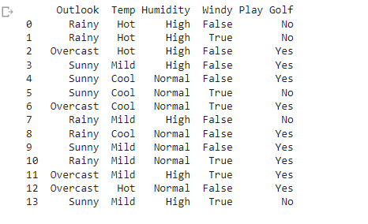

df1.head(10)

**Output Screenshot**

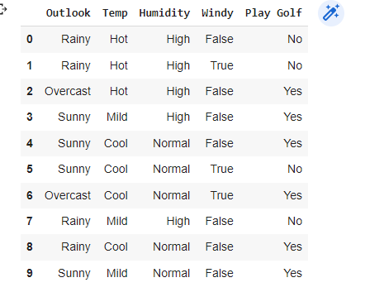

X = df1.iloc[:, [0,1,2, 3]].values

y = df1.iloc[:, -1].values

print(X)

print(y)

**Output Screenshot**

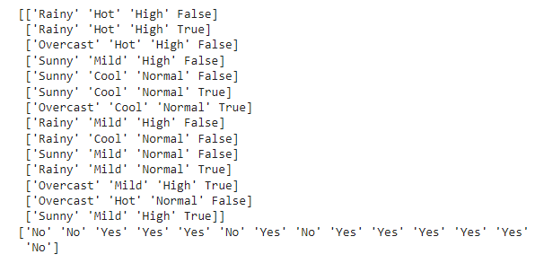

from sklearn.model_selection import train_test_split

X_train, X_test, y_train, y_test = train_test_split( X, y, test_size = 0.2, random_state=42)

print(X_test)

**Output Screenshot**

